Part A CODE
#include <stdio.h>
#include <stdlib.h>

// 1. Declare global variables so all functions can see them
int stack[100];
int top = -1;

void display();

int main() {
int ch, x;
do {
printf("\n--- MENU ---\n");
printf("1. Push\n2. Pop\n3. Exit\nEnter your choice: ");
scanf("%d", &ch);

switch (ch) {
case 1:
if (top == 99) { // Boundary check: isFull
printf("Stack Overflow\n");
} else {
printf("Enter an item: ");
scanf("%d", &x); // 2. FIX: Added '&' to x
stack[++top] = x;
display();
}
break;
case 2:
if (top == -1) { // Boundary check: isEmpty
printf("The stack is empty\n");
} else {
printf("Deleted element is %d\n", stack[top--]);
display();
}
break;
case 3:
printf("Exiting...\n");
exit(0);
default:
printf("Invalid choice!\n");
}
} while (ch != 3);
return 0;
}

void display() {
if (top == -1) {
printf("Stack is empty\n");
} else {
printf("Stack elements are:\n");
// 3. FIX: Loop downwards from top to 0
for (int i = top; i >= 0; i--) {
printf("%d\n", stack[i]);
}}}

Output Table
Sr. No. | INPUT | EXPECTED OUTPUT | ACTUAL OUTPUT
 | Compiling and running | --- MENU ---  1. Push  2. Pop  3. Exit  Enter your choice: | 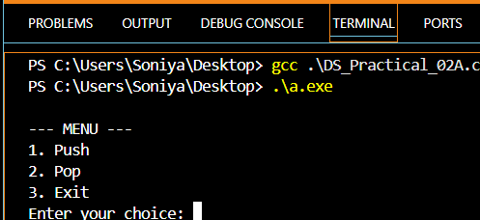
 | --- MENU ---  1. Push  2. Pop  3. Exit  Enter your choice:1  Enter an item: 11 | Stack elements are:  11 | 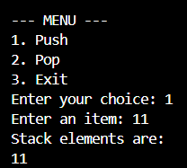
 | --- MENU ---  1. Push  2. Pop  3. Exit  Enter your choice:2 | Deleted element is 44  Stack elements are:  33  22  11 | 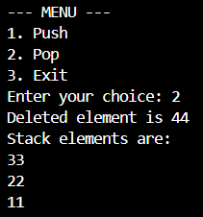
 | --- MENU ---  1. Push  2. Pop  3. Exit  Enter your choice:3 |  | 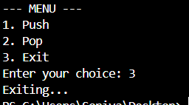
 | --- MENU ---  1. Push  2. Pop  3. Exit  Enter your choice:2  (When all elements are deleted) | The Stack is empty | 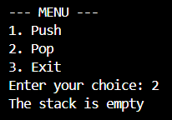

Part B CODE
#include <stdio.h>
#include <ctype.h>
#include <string.h>
#define MAX 200
char stack[MAX];
int top = -1;
void push(char c) { if (top < MAX-1) stack[++top] = c; }
char pop(void) { if (top >= 0) return stack[top--]; return '\0'; }
char peek(void) { if (top >= 0) return stack[top]; return '\0'; }
int isEmpty(void) { return top == -1; }
int precedence(char op) {
if (op == '+' || op == '-') return 1;
if (op == '*' || op == '/') return 2;
if (op == '^') return 3;
return 0;
}
/* Simple infix to postfix converter for assignment - concise version */
void infixToPostfix(const char *infix, char *postfix) {
top = -1;
int i = 0, j = 0;
while (infix[i]) {
char c = infix[i];
if (c == ' ' || c == '\t') { i++; continue; }
if (isalnum((unsigned char)c)) { postfix[j++] = c; i++; continue; }
if (c == '(') { push(c); i++; continue; }
if (c == ')') {
while (!isEmpty() && peek() != '(') postfix[j++] = pop();
if (!isEmpty() && peek() == '(') pop();
i++; continue;
}
while (!isEmpty() && peek() != '(') {
char topOp = peek();
int pTop = precedence(topOp);
int pCur = precedence(c);
if (pTop > pCur || (pTop == pCur && c != '^')) postfix[j++] = pop();
else break;
}
push(c); i++;
}
while (!isEmpty()) { char t = pop(); if (t != '(' && t != ')') postfix[j++] = t; }
postfix[j] = '\0';
}

int main(void) {
char infix[MAX], postfix[MAX];
printf("Enter infix expression:\n");
scanf("%s", infix);
infixToPostfix(infix, postfix);
printf("Postfix: %s\n", postfix);
return 0;
}

Output Table
Sr. No. | INPUT | EXPECTED OUTPUT | ACTUAL OUTPUT
 | Compiling and running | Enter infix expression: | 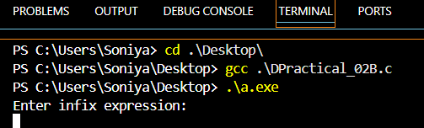
 | Enter infix expression:  A + B * C | Postfix: ABC*+ | 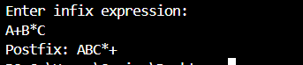
 | Enter infix expression:  a * ( b + c ) / d |  | 